Year 10 Semester One - Paper C

Mathematics Examination
Part One: NO Calculators Allowed

Name ________________________________ Teacher _______________________

TIME ALLOWED FOR THIS PAPER
Reading time before commencing : 5 minutes.
Working time for paper : 50 minutes.

MATERIAL REQUIRED /RECOMMENDED FOR THIS PAPER

TO BE PROVIDED BY THE SUPERVISOR
This question paper comprising 6 questions.
Attempt ALL questions.
Total marks for the paper : 75
Answers are to be written on this test booklet in the spaces provided.

TO BE PROVIDED BY THE CANDIDATE
Pens, pencils, eraser, ruler, protractor
One (1) A4 pages of notes (handwritten, photocopied or typed on both sides) that may be either personally or commercially produced.

INSTRUCTIONS TO CANDIDATES
Write all answers in the spaces provided - if working is completed on extra pages, indicate on the original question that your working continues elsewhere.
If extra paper is needed in any section, please ask one of the supervisors.

Show all working clearly, in sufficient detail to allow your answers to be checked readily and for marks to be awarded for reasoning. No marks will be awarded to incorrect answers without supporting reasoning.

Question | Possible Marks | Your Mark
1 | 19
2 | 15
3 | 10
4 | 14
5 | 7
6 | 10
Total | 75
Question 1 [19 marks]

a) Give TWO fractions that mean the same as:
(i) (ii)

[4]
b) Simplify the following fractions:
(i) (ii)

[2]
c) Which is bigger 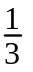 or ? Explain why.

[2]
d) Evaluate these:
(i) of 20 (ii) 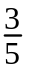 of 20

(iii) of 60 (iii) of 60

[4]
e) What is the result of of ? Explain your answer.

[2]
f) (i) Angela gave half of the chocolate bar to her younger sister and a quarter of it to her mum. What fraction did she have left for herself?

[2]

(ii) Simone lent a quarter of her textas to a friend. She then found out that half of the textas she had left did not work very well. There were 15 that worked. How many textas did she have before she lent any out?

[3]
Question 2 [15 marks]

a) Complete the following table, expressing fractions in their simplest form.

Fraction | Decimal | Percentage
 | 0.25
 |  | 10%
 | 0.15
 |  | 100%

[6]
b) Calculate the following percentages

(i) 10% of $25 (ii) 20% of $3.50

(iii) 10% of $3.50 (iv) 5% of $25

[4]

c) Target advertised a storewide discount of 20% off everything. How much would you pay on a top that was marked at $30 before the discount?

[2]

d) Brian got 7 out of 10 for Test one and 36 out of 50 for Test two. Which test result was better? Show how you arrived at your answer.

[3]
Question 3 [10 marks]

a) (i) 2  2  2 can be written as 2³. Evaluate 2³ .

(ii) Evaluate 2⁵.

[2]

b) c  c  c  d can be simplified to c ³d using index notation.
2  c 3  d d simplifies to 6cd ².

Simplify the following using index notation.

(i) f  f  f  f  f  f  f

(ii) 3  f  4  f

(iii) 5  f  f  f  f

(iv) 5  h  2  j  j  j  n  n

[4]
c) Write 4a³b² in expanded form.

[2]

d) Consider the following

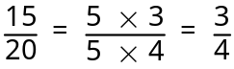

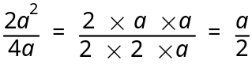

What would 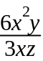 simplify to?

[2]
Question 4 [14 marks]

Consider the following diagrams.

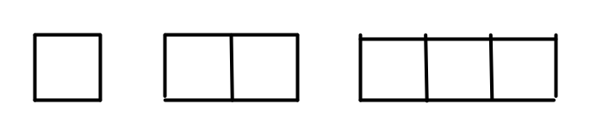
(i) Draw the next two diagrams in the pattern (in the space above).
[2]
(ii) Complete the following table:

Diagram number (x) | 1 | 2 | 3 | 4 | 5 | 10
Number of lines (y) | 4 | 7 |  |  |  |  | 46

[5]
(iii) Describe how to get the number of lines from the diagram number.

[2]

(iv) Write your rule using symbols.

[2]
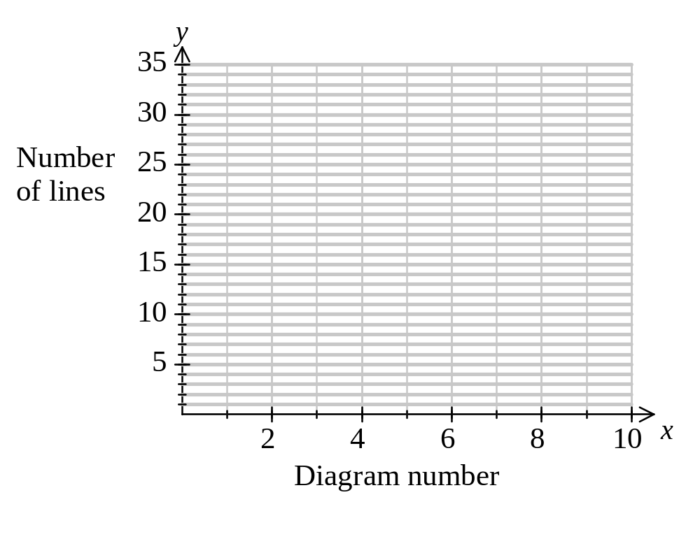 (v) Use the information in the table to draw an appropriate line graph on the axes below.

[3]
Question 5 [7 marks]

a) The formula that can be used to find the volume, V cm³ of a rectangular prism is
V = lwh.

Find V when:

(i) l = 4, w = 6, h = 2.

(ii) l = 10, w = 10, h = 10.

[4]

c) A number is multiplied by 4 and then increased by 8. The result equals 20.

(i) Let the number be n. Write an equation that matches the situation.

(ii) What is the number?

[3]
Question 6 [10 marks]

a) (i) Make an accurate drawing of the following triangle.

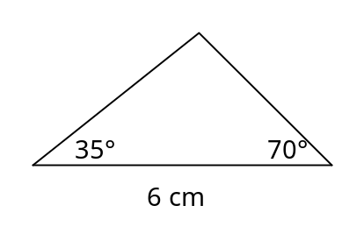

[3]
(ii) Classify the triangle. Choose words from the following: scalene, isosceles, right, obtuse, acute, equilateral.

[2]

b) (i) Make an accurate drawing of a parallelogram that has sides of 5 cm and 3 cm.

[3]
(ii) Is it possible to draw another parallelogram with the same measurement that will look different from the one you just drew? Explain.

[2]

